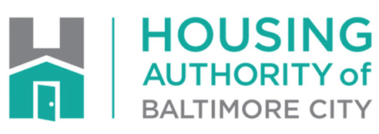**Joseph L. Smith**, *Chairman, Board of Commissioner*

**Janet Abrahams**, *Chief Executive Officer*

**PRESS RELEASE**

**For Immediate Release: CONTACTS:** Ingrid Antonio 410-396-4564

Ingrid.antonio@habc.org

Brian Dries - 717-495-5509

**Housing Authority of Baltimore City Launches “Everybody is at Risk” Campaign to Prevent Spread of COVID-19**

*Housing agency wants residents to know the virus does not discriminate,   
impacting African-Americans at much higher rate in the city*

**BALTIMORE (April 21, 2020)** - The Housing Authority of Baltimore City (HABC) has launched a public awareness campaign “Everybody is at Risk” to inform and educate residents about the importance of practicing social distancing at all times in an effort to slow the spread of COVID-19.

While HABC’s communities have not realized reported cases of COVID-19, the agency took the initiative to raise awareness as the battle against the virus is far from over and all actions in the next few weeks are critical. HABC has placed 250 yard signs throughout all of its resident communities to remind residents to remain six feet apart.

“The aim of our ‘Everybody is at Risk’ COVID-19 awareness and prevention campaign is to compel our residents to acknowledge the role they play in keeping the entire HABC community safe and take action to prevent the spread of COVID-19,” said HABC CEO Janet Abrahams.

“Everybody is at risk of contracting the virus and positive cases in Maryland and Baltimore have been reported across every demographic. COVID-19 doesn’t discriminate, a fact that makes the rates of infection among African-Americans and the elderly even more troubling.”

In the City of Baltimore, infection rates are disproportionately higher among communities of color and the elderly. Of the total reported positive COVID-19 cases in Baltimore City, 805 are African-American compared with 687 positive cases among all other races, according to city data. Meanwhile the rate of infection per capita in those over 80-years-old is 64 percent higher in Baltimore (8.2 per 1,000) than all of Maryland (5.0 per 1,000).

“There are many aspects of the current public health crisis that are outside of our control, which makes it vital that we focus on what we can control,” said HABC CEO Janet Abrahams. “Adjustments to our daily behaviors are necessary to keep our residents, their families and the Baltimore community safe.

“We know hospitalization rates in Maryland are showing signs of stabilization, the result of social distancing, sheltering at home, and other measures aimed at containing the virus.”

In addition to the “Everybody is at Risk” yard signs, HABC communities will see signs and other materials urging them to practice social distancing, engage in frequent handwashing, and wear face masks, among other behavioral changes.

The campaign is part of HABC’s efforts to keep its residents and staff safe and healthy. It has launched several initiatives throughout the pandemic including meal delivery services, food and product donations and informing residents of all directives and guidelines as provided by the CDC and state and local health departments.

###